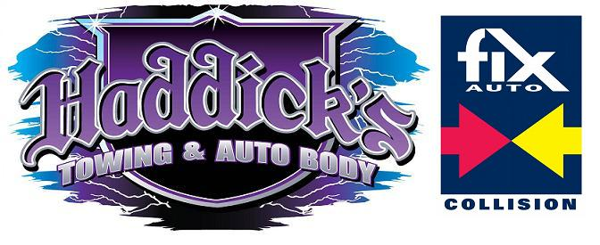
Limited Power of Attorney
I, ___________________________, do hereby authorize___________________________
And/or its agents, representatives, associates, or its affiliate’s_________________, to pick up my property from my, (Year) __________ (Make) ______________ (Model)_______________
(License Plate)______________ (Vehicle ID Number VIN)_______________________________
That was towed on ___/___/______. I hereby authorize my agents to sign any and all documents and release on my behalf, and to sign all paper work and documents necessary to have my property released. A faxed/photocopy of this authorization shall be considered as valid as the original. All my personal property within/or attached to the vehicle is the responsibility of my agent once removed from Haddick’s Towing, Inc. I am aware my agent will only be allowed to remove loose property nothing that is bolted, wired, attached, or required tools to remove. Such as wheels, engine parts, stereo system, speakers, subwoofers, racks, interior or dash parts.
I hereby release Haddick’s Towing, Inc. of all responsibility and liability pertaining of the described vehicles property.
Executed on __________in (City) ______________________________, (State) _________

______________________________ _______________________________________
Signature of Registered Owner Printed name

(Photo copy of registered owners identification here)

